

ENTRY FORM
RACE NUMBER

DATE: 29 JUNE 2025
START & FINISH: Beacon Bay Crossing

TIME :21.1km @ 07h00 Entry Fee: R150 (Temp. Lic. R60)
4km @ 07h10 Entry fee R40
2.1km @ 07H15 Entry Fee: R20

Personal Details

Surname…………………………………........ Name………………………………….. Age………….

Club………………………………………………….Lic.No.:………… Gender F M

ID no.:……………………………………………………. Date of Birth:…………………………….................................

2.1km 4km 21km Contact Details:…………………………………………
Compulsory for sms results purposes

Next of Kin details: Name:…………………………….Contact#:…………………………………

Open Jr 35+ 40+ 50+ 60+

I declare that I participate at my own risk & will not hold event organizers/sponsors liable for any loss/damage to property or injury incurred during my participation in this event.

Signature…………………………………………

General information and race rules

Online entries OPEN from 21 April 2025
https://www.webtickets.co.za/event.aspx?itemid=1567776636
Manual entries open on 26 May 2025
Race run under & in strict accordance with ASA & Border Athletics (BA) rules
Race number to be worn in front on the outermost piece of clothing.
ASA licence numbers to be worn front & back as per ASA rules
Online entries close on the 23 June 2025 @ 23h59
Manual entries close on the 27 June 2025 @ 12h00

Participating sport shops:
Sportsmans Warehouse, Beacon Bay
Golden Palace, Mdantsane City Mall

Late entries and ONLINE race number collection at:
Eastern Cape Liquor Board, Beacon Bay Crossing, 10 Bonza Bay Road
27 June, 13h00 – 17h00 & 28 June 10h00 – 17h00
** ENTRIES ON RACE DAY AT AN ADDITIONAL FEE OF R50
* MAIN RACE DATE & START TIME: 29 June 2025, 07H00
No race number, no results, no hand-out

Medals & t-shirts to 1st 800 (21.1km)
Medals to all finishers (2.1 & 4 km)

ECLB 21KM AWARENESS RUN Prize Money
Position 1 2 3 4 5
Open R 6 000 R4 000 R3 000 R2 000 R1 000
Categories R 1 500 R1 300 R1 000
for more information contact:
Andiswa: 083 311 7886 / Ayanda: 079 438 0821 / Sazi: 066 475 6325
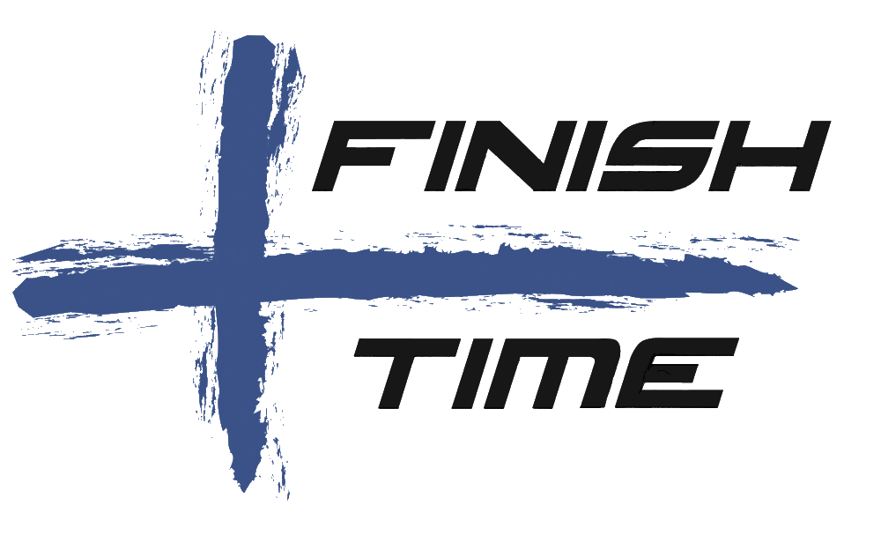
RUNNING AGAINST UNDER-AGE DRINKING 